Mini test pre-exam

1. Object Pronouns
2. Choose the correct pronoun.
3. Listen to me/I. 6. We are listening to she/you.
4. Did you meet her/she? 7. Dad took we/us to the zoo.
5. The cat ate it/its all. 8. Nobody hates he/him.
6. She teaches them/they math. 9. Give I/me the pencil, please.
7. I left he/him at home. 10. Stop shouting at us/we.
8. Replace the underlined word with the correct object pronoun.
9. Deku loves All Might merch. ________________
10. Shigaraki hates All Might. ________________
11. Is this caramel apple for you and Eri? ________________
12. Deku hates villains. ________________
13. You broke the plate. ________________
14. Bakugou is talking to Kirishima and Denki. ________________
15. Don´t play with fire Dabi. ________________
16. Endeavors agency belongs to the Todoroki family. ________________
17. Come with Aizawa sensei and me. ________________
18. Uraraka took Momo to the shopping mall. ________________
19. Look at the pictures and complete the sentences using “look at” with the correct object pronoun.  
    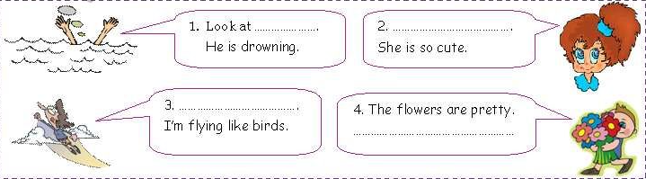
20. Fill in the blanks with the correct subject or object pronoun.
21. Did you see the cat? _________ was sleeping on the mat.
22. I always trusted you, but ________ never trusted _________.
23. I can´t find my keys. Where are __________?
24. Everyone loves my mother. __________ is very kind.
25. Before you eat the strawberries, you have to wash _________ very well.
26. Jack and I missed the bus today, so _________ reached the school late.
27. My little brother is sick today. My mother is taking ______ to the doctor.
28. Don´t look at ________ like this. _______ makes me feel embarrassed.
29. I like Mrs. Kennedy, my language arts teacher. ________ is very nice.
30. We brought a horror movie. Would you like to watch _____ with _____?
31. Anya´s room is very messy. Her dad asked ______ to clean _____ up.
32. Can you call Mr. Aizawa please? Sorry, but I don´t know ______.
33. We were very tired last night, so ______ went to sleep early.
34. Bakugou is always angry. _______ always is shouting at others.
35. What is the name of this movie? I´m not sure, but I can´t remember ___.
36. My dad is a hero. _____ works in the Endeavor Agency.
37. The students are outside. _______ are training in the camp.
38. My uniform is very dirty. I have to clean ____.
39. Todoroki/Momo is here. Please, let ________________ in.
40. Kirisihima and you were absent yesterday. I was worried about _____ both.
41. Must/Mustn´t
42. 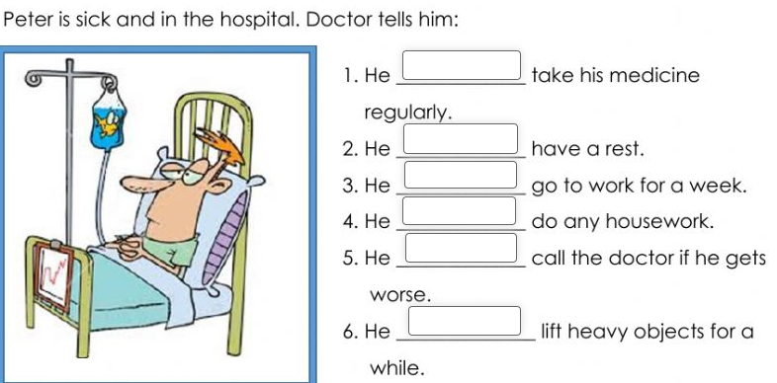Complete eache sentence with must or mustn´t
43. 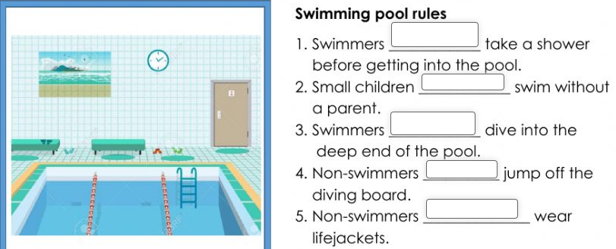Complete each sentence with must or mustn´t
44. Write 3 sentences using must.
45. ___________________________________________________________
46. ___________________________________________________________
47. ___________________________________________________________
48. Write 3 sentences using mustn´t.
49. ___________________________________________________________
50. ___________________________________________________________
51. ___________________________________________________________
52. Can/Can´t
53. Write 3 things with CAN.
54. ________________________________________________________
55. ________________________________________________________
56. ________________________________________________________
57. Write 3 thing with CAN´T
58. ________________________________________________________
59. ________________________________________________________
60. ________________________________________________________
61. 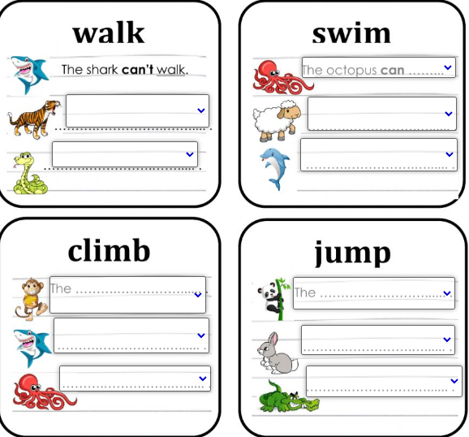Tell if these animals CAN or CAN´T
62. Adverbs of frequency
63. Complete the sentence using adverbs of frequency
64. I ___________ watch anime at home. 75%
65. Anya ______________ study before sleeping. 0%
66. Loid _______________ go to the beach on summer. 100%
67. Yor _______________ is sent to a mission. 90%
68. The Forger family ____________ go to the park at the weekend. 50%
69. Tabla

    Descripción generada automáticamenteFind the adverbs of frequency in the wordsearch.  
    (Always, usually, often, sometimes, never)
70. Write 5 sentences about you using adverbs of frequency.
71. ________________________________________________________________________________________________________________
72. ________________________________________________________________________________________________________________
73. ________________________________________________________________________________________________________________
74. ________________________________________________________________________________________________________________
75. ________________________________________________________________________________________________________________
76. Gráfico

    Descripción generada automáticamenteForma, Rectángulo

    Descripción generada automáticamenteRegular/Irregular Verbs (Conjugation)  
    A) Match crrectly.  
    Imagen que contiene Gráfico

    Descripción generada automáticamente

B) Change the vowel

C)  
Read the sentences and the complete with the correct form of the given verbs.

a. Tony ____________ (tell) me a very funny story yesterday.

b. Sam ____________ (clean) her bedroom yesterday.

c. It was hot in the room, so I ________ (open) the window.

d. Jill __________ (write) a letter to a friend yesterday.

e. My boss _________ (take) a take from the airport to her hotel.

f. When I was a child, I ___________ (want) to be a vet.

g. My friend and I ___________ (finish) our homework a few minutes ago.

h. Susan __________ (like) her friend´s new handbag.

i. Joe __________ (break) his mug this morning on accident.

j. I ___________ (meet) my bestfriend in 2009 in kindergarden.

k. My teacher ___________ (go) to the cinema yesterday.

l. I ___________ (watch) a very nice film yesterday.

m. Uraraka _______ (make) someone float on accident.

n. We ___________ (play) beach volleyball when we went to the beach.

o. She ____________ (listen) to music in class during chemistry.

p. I ________ (get) a lot of mangas for my birthday.

q. Nezuko was so thirsty. She _________ (drink) two glasses of water.

r. Her father ___________ (work) with globant in 2019?